PKBee NT 6W 2013v1
Description : Revision/Connection of the PKBee Transmitter
Date : 24-11-2013
by : H.Slot
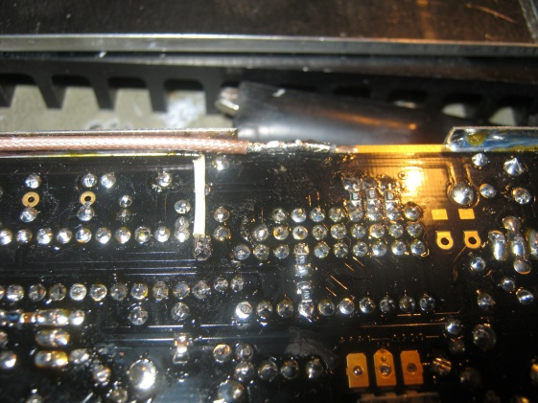
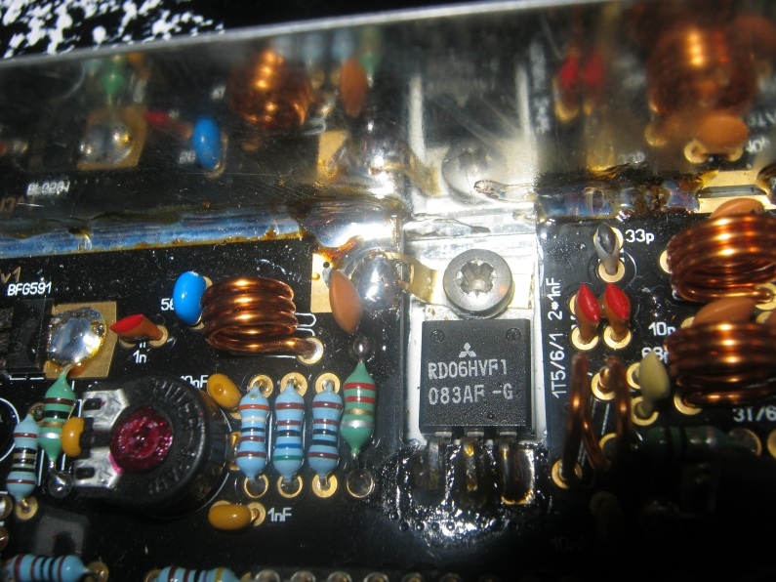
1)
22/11 : Aanpassing vanwege het niet werken LCD.
1) Draadbrug vanwege ontbreken massa punt.
22/11 : Aanpassing.
1) Condensator 15pF vanwege misaanpassing buffer <-> eindtrap.
Soldeerlip voor een betere massa aansluiting

2)

